**LAPORAN PRAKTIKUM INTERNET OF THINGS**

**(IoT)**



Disusun oleh:

|  |  |
| --- | --- |
| Abdul Rochman | (233140701111023) |

**Universitas Brawijaya**

**Fakultas Vokasi**

**Teknologi Informasi**

**2025**

**ABSTRAK**

Praktikum ini membahas pembuatan tampilan dashboard web untuk memvisualisasikan data dari perangkat IoT secara real-time. Dengan memanfaatkan teknologi berbasis web (seperti HTML, CSS, dan JavaScript) serta integrasi dengan backend Laravel, mahasiswa mempelajari bagaimana antarmuka monitoring data sensor dapat dirancang secara interaktif.

Keywords— *IoT, HTML, CSS, JavaScript*

**1. PENDAHULUAN**

**1.1 Latar Belakang**

Dalam sistem Internet of Things (IoT), visualisasi data merupakan salah satu aspek penting untuk memahami dan mengelola informasi sensor secara cepat dan efisien. Salah satu bentuk visualisasi data adalah melalui **dashboard web**, di mana data dari perangkat seperti ESP32 ditampilkan dalam bentuk grafik, tabel, dan indikator status. Pada praktikum ini, digunakan simulasi perangkat melalui **Wokwi**, dan data dikirim ke **Laravel API** kemudian divisualisasikan di **halaman web dashboard**.

**1.2 Tujuan eksperimen**

1. Membuat tampilan web dashboard untuk data sensor dari perangkat IoT.
2. Menampilkan data dari ESP32 (simulasi) secara real-time atau periodik.

**2. METODOLOGI**

**2.1 Alat & Bahan**

Berikut adalah tools yang digunakan dalam praktikum ini

* Visual Studio Code.
* Wokwi.
* Laravel.
* Ngrok.
* Xampp

**2.2 Langkah Implementasi**

Langkah-langkah implementasi dalam membuat lampu lalu lintas adalah sebagai berikut.

1. Buka folder praktik 12
2. Install composer maatwebsite
3. Buat controller dengan nama GraphController dengan perintah php artisan make:controller GraphController
4. Sesuaikan GraphController
5. Buat file export baru dengan perintah php artisan make:export TransaksiSensorExport—model=TransaksiSensor
6. Sesuaikan file export
7. Sesuaikan file web.php di folder routes
8. Buat file graph.blade.php di folder resources/views
9. Sesuaikan isi file graph.blade.php
10. Jalankan atau uji kode

**3. HASIL DAN PEMBAHASAN**

**3.1 Hasil Eksperimen**

Penulis berhasil membuat tampilan dashboard sesuai dengan modul pada bab 15.

1. Instalasi composer maatwebsite/excel

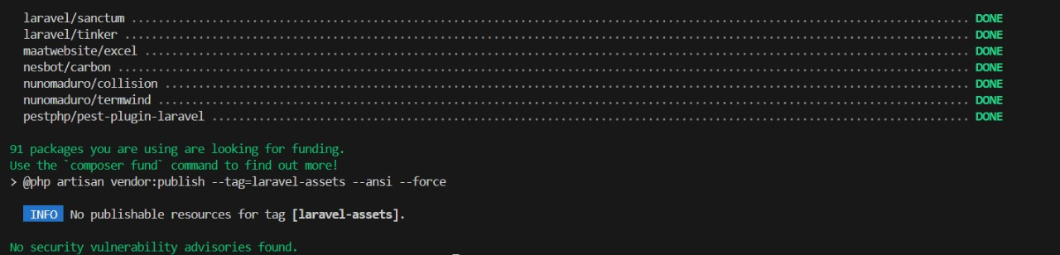

1. File GraphController

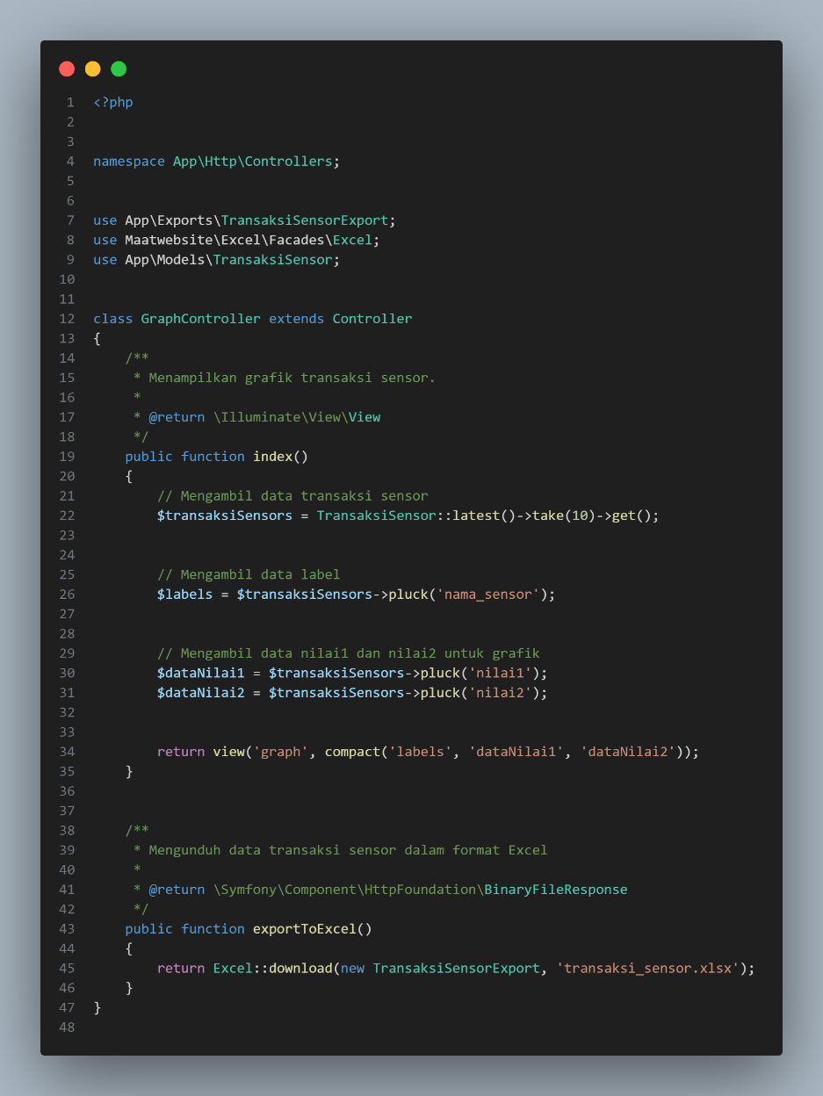

1. TransaksiSensorExport

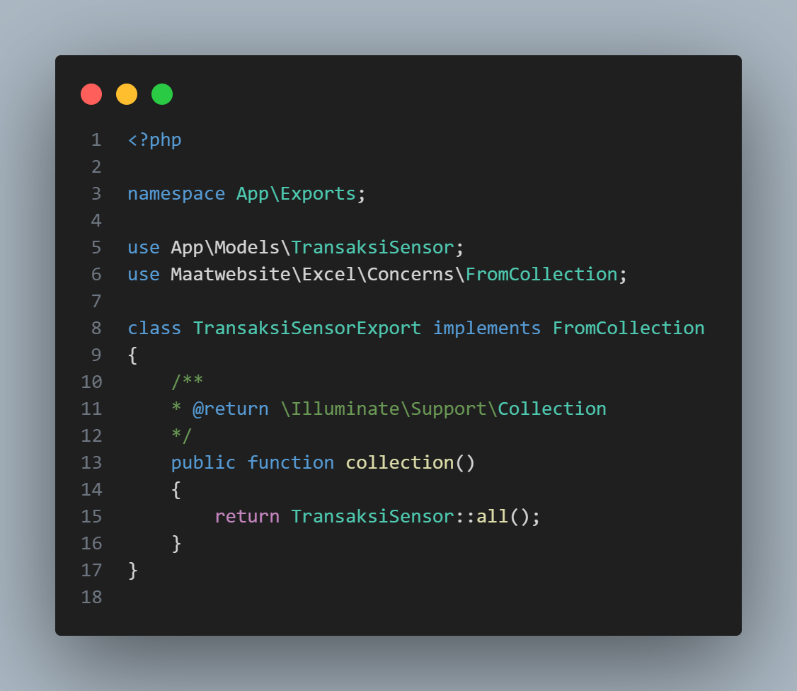

1. Web.php

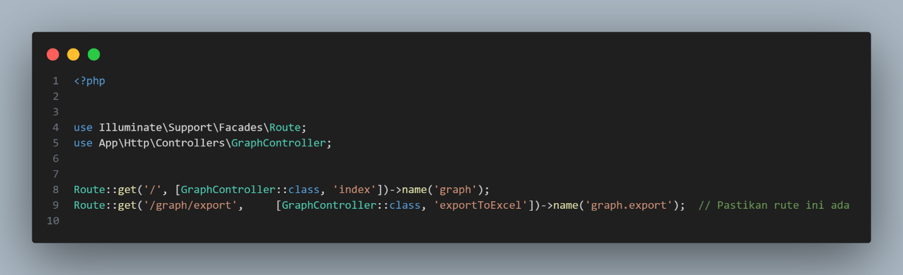

1. graph.blade.php

<!DOCTYPE html>

<html lang="id">

<head>

    <meta charset="UTF-8">

    <meta name="viewport" content="width=device-width, initial-scale=1.0">

    <title>Dashboard Monitoring Sensor | Sistem IoT</title>

     <link rel="stylesheet" href="https://cdnjs.cloudflare.com/ajax/libs/font-awesome/6.4.0/css/all.min.css">

     <link href="https://fonts.googleapis.com/css2?family=Poppins:wght@300;400;500;600;700&display=swap" rel="stylesheet">

    <script src="https://cdn.jsdelivr.net/npm/chart.js"></script>

    <link rel="stylesheet" href="https://cdnjs.cloudflare.com/ajax/libs/animate.css/4.1.1/animate.min.css">

    <style>

        :root {

            --primary-color: #4361ee;

            --primary-light: #e0e7ff;

            --secondary-color: #3f37c9;

            --accent-color: #4cc9f0;

            --accent-light: #e0fbfc;

            --success-color: #4bb543;

            --warning-color: #f8961e;

            --danger-color: #f94144;

            --light-color: #f8f9fa;

            --dark-color: #212529;

            --gray-color: #6c757d;

        }

        * {

            margin: 0;

            padding: 0;

            box-sizing: border-box;

        }

        body {

            font-family: 'Poppins', sans-serif;

            background: linear-gradient(135deg, #f5f7fa 0%, #e2e8f0 100%);

            min-height: 100vh;

            padding: 2rem 1rem;

            color: var(--dark-color);

            line-height: 1.6;

        }

        .dashboard-container {

            max-width: 1200px;

            margin: 0 auto;

        }

        .header {

            display: flex;

            justify-content: space-between;

            align-items: center;

            margin-bottom: 2rem;

            flex-wrap: wrap;

            gap: 1rem;

        }

        .header-title {

            font-size: 1.8rem;

            font-weight: 600;

            color: var(--primary-color);

            display: flex;

            align-items: center;

            gap: 0.75rem;

        }

        .header-title i {

            color: var(--accent-color);

        }

        .card {

            background-color: white;

            border-radius: 12px;

            box-shadow: 0 4px 20px rgba(0, 0, 0, 0.08);

            padding: 1.75rem;

            margin-bottom: 2rem;

            transition: transform 0.3s ease, box-shadow 0.3s ease;

        }

        .card:hover {

            transform: translateY(-5px);

            box-shadow: 0 8px 30px rgba(0, 0, 0, 0.12);

        }

        .card-header {

            display: flex;

            justify-content: space-between;

            align-items: center;

            margin-bottom: 1.5rem;

            padding-bottom: 1rem;

            border-bottom: 1px solid rgba(0, 0, 0, 0.05);

        }

        .card-title {

            font-size: 1.25rem;

            font-weight: 600;

            color: var(--primary-color);

            display: flex;

            align-items: center;

            gap: 0.75rem;

        }

        .card-title i {

            font-size: 1.1em;

        }

        .card-actions {

            display: flex;

            gap: 0.75rem;

        }

        .btn {

            padding: 0.5rem 1rem;

            border-radius: 8px;

            border: none;

            font-weight: 500;

            font-size: 0.9rem;

            cursor: pointer;

            transition: all 0.3s ease;

            display: inline-flex;

            align-items: center;

            gap: 0.5rem;

        }

        .btn-primary {

            background-color: var(--primary-color);

            color: white;

        }

        .btn-primary:hover {

            background-color: var(--secondary-color);

        }

        .btn-outline {

            background-color: transparent;

            border: 1px solid var(--primary-color);

            color: var(--primary-color);

        }

        .btn-outline:hover {

            background-color: var(--primary-color);

            color: white;

        }

        .btn-success {

            background-color: var(--success-color);

            color: white;

        }

        .btn-success:hover {

            opacity: 0.9;

        }

        .chart-container {

            position: relative;

            height: 400px;

            width: 100%;

            margin-bottom: 1.5rem;

        }

        .data-summary {

            display: grid;

            grid-template-columns: repeat(auto-fit, minmax(250px, 1fr));

            gap: 1.25rem;

            margin-top: 1.5rem;

        }

        .summary-card {

            background-color: white;

            border-radius: 10px;

            padding: 1.25rem;

            box-shadow: 0 2px 10px rgba(0, 0, 0, 0.05);

            transition: transform 0.2s ease;

        }

        .summary-card:hover {

            transform: translateY(-3px);

        }

        .summary-header {

            display: flex;

            justify-content: space-between;

            align-items: center;

            margin-bottom: 0.75rem;

        }

        .summary-title {

            font-size: 0.9rem;

            font-weight: 500;

            color: var(--gray-color);

        }

        .summary-icon {

            width: 36px;

            height: 36px;

            border-radius: 8px;

            display: flex;

            align-items: center;

            justify-content: center;

            font-size: 1rem;

        }

        .sensor-1 {

            background-color: var(--primary-light);

            color: var(--primary-color);

        }

        .sensor-2 {

            background-color: var(--accent-light);

            color: var(--accent-color);

        }

        .summary-value {

            font-size: 1.5rem;

            font-weight: 600;

            margin-bottom: 0.25rem;

        }

        .summary-change {

            font-size: 0.85rem;

            display: flex;

            align-items: center;

            gap: 0.25rem;

        }

        .positive {

            color: var(--success-color);

        }

        .negative {

            color: var(--danger-color);

        }

        .neutral {

            color: var(--gray-color);

        }

        .time-selector {

            display: flex;

            justify-content: flex-end;

            gap: 0.5rem;

            margin-bottom: 1rem;

        }

        .time-btn {

            padding: 0.35rem 0.75rem;

            border-radius: 6px;

            background-color: var(--light-color);

            border: none;

            font-size: 0.85rem;

            cursor: pointer;

            transition: all 0.2s ease;

        }

        .time-btn.active {

            background-color: var(--primary-color);

            color: white;

        }

        .time-btn:hover:not(.active) {

            background-color: #e9ecef;

        }

        @media (max-width: 768px) {

            .header {

                flex-direction: column;

                align-items: flex-start;

            }

            .chart-container {

                height: 300px;

            }

            .data-summary {

                grid-template-columns: 1fr;

            }

            .card-actions {

                width: 100%;

                justify-content: space-between;

            }

        }

        .fade-in {

            animation: fadeIn 0.6s ease-in-out;

        }

        @keyframes fadeIn {

            from { opacity: 0; transform: translateY(10px); }

            to { opacity: 1; transform: translateY(0); }

        }

    </style>

</head>

<body>

    <div class="dashboard-container">

        <div class="header animate__animated animate__fadeIn">

            <h1 class="header-title">

                <i class="fas fa-chart-network"></i>

                Dashboard Monitoring Sensor

            </h1>

            <div class="time-selector">

                <button class="time-btn active">24 Jam</button>

                <button class="time-btn">7 Hari</button>

                <button class="time-btn">30 Hari</button>

                <button class="time-btn">Custom</button>

            </div>

        </div>

        <div class="card animate__animated animate__fadeIn animate__delay-1s">

            <div class="card-header">

                <h2 class="card-title">

                    <i class="fas fa-wave-square"></i>

                    Grafik Perbandingan Sensor

                </h2>

                <div class="card-actions">

                    <button class="btn btn-outline" onclick="window.location.href='{{ route('graph.export') }}'">

                        <i class="fas fa-download"></i> Export

                    </button>

                </div>

            </div>

            <div class="chart-container">

                <canvas id="sensorChart"></canvas>

            </div>

            <div class="data-summary">

                <div class="summary-card fade-in">

                    <div class="summary-header">

                        <span class="summary-title">Sensor 1 (Rata-rata)</span>

                        <div class="summary-icon sensor-1">

                            <i class="fas fa-thermometer-half"></i>

                        </div>

                    </div>

                    <div class="summary-value" id="avg-sensor1">0</div>

                    <div class="summary-change positive">

                        <i class="fas fa-arrow-up"></i> <span id="change-sensor1">0%</span> dari periode sebelumnya

                    </div>

                </div>

                <div class="summary-card fade-in">

                    <div class="summary-header">

                        <span class="summary-title">Sensor 2 (Rata-rata)</span>

                        <div class="summary-icon sensor-2">

                            <i class="fas fa-thermometer-quarter"></i>

                        </div>

                    </div>

                    <div class="summary-value" id="avg-sensor2">0</div>

                    <div class="summary-change negative">

                        <i class="fas fa-arrow-down"></i> <span id="change-sensor2">0%</span> dari periode sebelumnya

                    </div>

                </div>

                <div class="summary-card fade-in">

                    <div class="summary-header">

                        <span class="summary-title">Korelasi</span>

                        <div class="summary-icon">

                            <i class="fas fa-link"></i>

                        </div>

                    </div>

                    <div class="summary-value" id="correlation-value">0.00</div>

                    <div class="summary-change neutral">

                        <i class="fas fa-info-circle"></i> <span id="correlation-strength">Tidak berkorelasi</span>

                    </div>

                </div>

            </div>

        </div>

    </div>

    <script>

        const labels = @json($labels);

        const dataNilai1 = @json($dataNilai1);

        const dataNilai2 = @json($dataNilai2);

        function calculateStats(data) {

            const sum = data.reduce((a, b) => a + b, 0);

            const avg = sum / data.length;

            const max = Math.max(...data);

            const min = Math.min(...data);

            return { sum, avg, max, min };

        }

        function calculateCorrelation(x, y) {

            const n = x.length;

            let sumX = 0, sumY = 0, sumXY = 0, sumX2 = 0, sumY2 = 0;

            for (let i = 0; i < n; i++) {

                sumX += x[i];

                sumY += y[i];

                sumXY += x[i] * y[i];

                sumX2 += x[i] * x[i];

                sumY2 += y[i] * y[i];

            }

            const numerator = sumXY - (sumX * sumY) / n;

            const denominator = Math.sqrt((sumX2 - (sumX * sumX) / n) * (sumY2 - (sumY * sumY) / n));

            return denominator === 0 ? 0 : numerator / denominator;

        }

        const stats1 = calculateStats(dataNilai1);

        const stats2 = calculateStats(dataNilai2);

        const correlation = calculateCorrelation(dataNilai1, dataNilai2);

        document.getElementById('avg-sensor1').textContent = stats1.avg.toFixed(2);

        document.getElementById('avg-sensor2').textContent = stats2.avg.toFixed(2);

        document.getElementById('change-sensor1').textContent = (Math.random() * 5).toFixed(1) + '%';

        document.getElementById('change-sensor2').textContent = (Math.random() * 3).toFixed(1) + '%';

        document.getElementById('correlation-value').textContent = correlation.toFixed(2);

        const correlationStrength = document.getElementById('correlation-strength');

        if (Math.abs(correlation) > 0.7) {

            correlationStrength.textContent = 'Korelasi kuat';

            correlationStrength.className = 'positive';

        } else if (Math.abs(correlation) > 0.3) {

            correlationStrength.textContent = 'Korelasi sedang';

            correlationStrength.className = 'neutral';

        } else {

            correlationStrength.textContent = 'Korelasi lemah';

            correlationStrength.className = 'negative';

        }

        const ctx = document.getElementById('sensorChart').getContext('2d');

        const chart = new Chart(ctx, {

            type: 'line',

            data: {

                labels: labels,

                datasets: [

                    {

                        label: 'Sensor 1',

                        data: dataNilai1,

                        borderColor: '#4361ee',

                        backgroundColor: 'rgba(67, 97, 238, 0.1)',

                        borderWidth: 2,

                        tension: 0.3,

                        fill: true,

                        pointBackgroundColor: 'white',

                        pointBorderColor: '#4361ee',

                        pointBorderWidth: 2,

                        pointRadius: 4,

                        pointHoverRadius: 6,

                        yAxisID: 'y'

                    },

                    {

                        label: 'Sensor 2',

                        data: dataNilai2,

                        borderColor: '#4cc9f0',

                        backgroundColor: 'rgba(76, 201, 240, 0.1)',

                        borderWidth: 2,

                        tension: 0.3,

                        fill: true,

                        pointBackgroundColor: 'white',

                        pointBorderColor: '#4cc9f0',

                        pointBorderWidth: 2,

                        pointRadius: 4,

                        pointHoverRadius: 6,

                        yAxisID: 'y'

                    }

                ]

            },

            options: {

                responsive: true,

                maintainAspectRatio: false,

                interaction: {

                    mode: 'index',

                    intersect: false

                },

                plugins: {

                    legend: {

                        position: 'top',

                        labels: {

                            usePointStyle: true,

                            padding: 20,

                            font: {

                                size: 13,

                                weight: '500'

                            }

                        }

                    },

                    tooltip: {

                        backgroundColor: 'rgba(0, 0, 0, 0.85)',

                        titleFont: {

                            size: 14,

                            weight: '600'

                        },

                        bodyFont: {

                            size: 13

                        },

                        padding: 12,

                        cornerRadius: 8,

                        usePointStyle: true,

                        callbacks: {

                            label: function(context) {

                                let label = context.dataset.label || '';

                                if (label) {

                                    label += ': ';

                                }

                                if (context.parsed.y !== null) {

                                    label += context.parsed.y.toFixed(2);

                                }

                                return label;

                            }

                        }

                    },

                    annotation: {

                        annotations: {

                            line1: {

                                type: 'line',

                                yMin: stats1.avg,

                                yMax: stats1.avg,

                                borderColor: '#4361ee',

                                borderWidth: 1,

                                borderDash: [5, 5],

                                label: {

                                    content: 'Rata-rata S1: ' + stats1.avg.toFixed(2),

                                    enabled: true,

                                    position: 'right',

                                    backgroundColor: 'rgba(67, 97, 238, 0.7)'

                                }

                            },

                            line2: {

                                type: 'line',

                                yMin: stats2.avg,

                                yMax: stats2.avg,

                                borderColor: '#4cc9f0',

                                borderWidth: 1,

                                borderDash: [5, 5],

                                label: {

                                    content: 'Rata-rata S2: ' + stats2.avg.toFixed(2),

                                    enabled: true,

                                    position: 'right',

                                    backgroundColor: 'rgba(76, 201, 240, 0.7)'

                                }

                            }

                        }

                    }

                },

                scales: {

                    y: {

                        beginAtZero: false,

                        grid: {

                            color: 'rgba(0, 0, 0, 0.05)'

                        },

                        ticks: {

                            font: {

                                size: 12

                            }

                        }

                    },

                    x: {

                        grid: {

                            display: false

                        },

                        ticks: {

                            font: {

                                size: 12

                            }

                        }

                    }

                },

                animation: {

                    duration: 1000,

                    easing: 'easeOutQuart'

                }

            }

        });

        // Time selector functionality

        document.querySelectorAll('.time-btn').forEach(btn => {

            btn.addEventListener('click', function() {

                document.querySelectorAll('.time-btn').forEach(b => b.classList.remove('active'));

                this.classList.add('active');

                chart.data.datasets.forEach(dataset => {

                    dataset.data = dataset.data.map(() => Math.random() * 100);

                });

                chart.update();

            });

        });

        window.addEventListener('resize', function() {

            chart.resize();

        });

    </script>

</body>

</html>

1. Testing

Hasil di Browser

